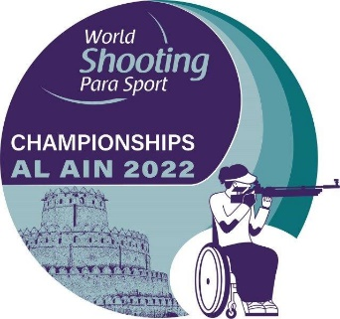

Note: Please send the completed form by email to the below contact details.

MEDICATION DECLARATION FORM |  | Please return by 20 October 2022 | to
Name of NPC |  | Phone Number: | Ms. Maha Fadl  Mobile: +971582090512  E-mail:Maha.Fadl@wsps.ae
Contact Person
Email Address
No | Athletes |  | Medication Name | Dosage | Frequency per day | Drug Class  (Pain killer, depressant, etc.)
 | Family Name | First Name

