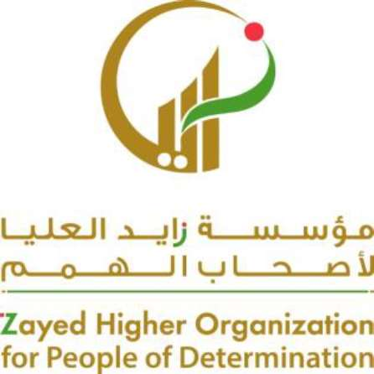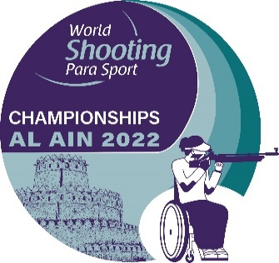

Visa support letter request form

Al Ain 2022 World Shooting Para Sport World Championship

Email to the Organizing Committee (MAHA.FADL@WSPS.AE ) by no later than 20 October, 2022

1

NPC |  | Name of  Organization
Contact Number |  | Phone
Email |  | Fax

2

